**Renew synchronisation SalesForce with Microsoft Outlook**  
  
Issue : SalesForce do not syncing mails in Outlook.

In Outlook software, you have a “SalesForce” plugin to sync automatically your emails.

**1/** Open the “SmartCloud Connect for SalesForce”  (Upper toolbar in Outlook)

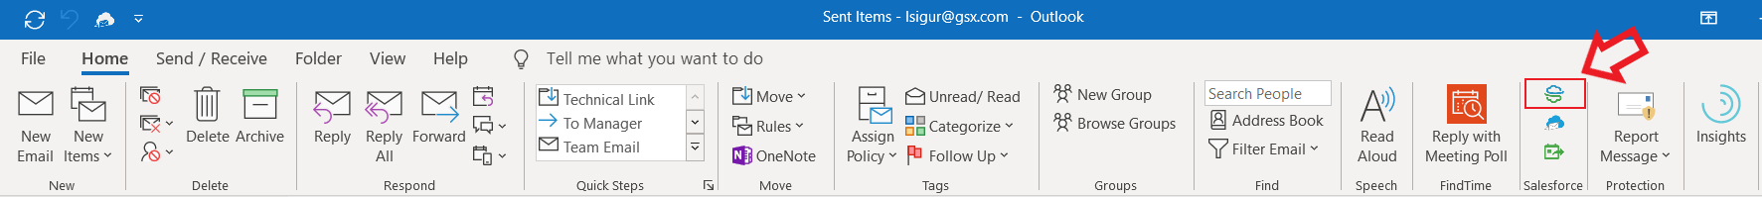

**2/** In the right panel, SalesForce is disconnected. Click on “Connect to SalesForces” (Not Sandbox)

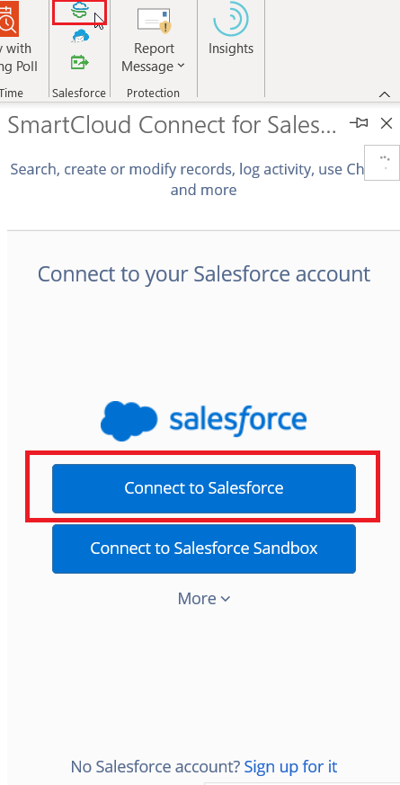

**3/** Your web browser will open and ask your SalesForces account.

* Enter your SalesForce account and select “Remember Me”. Click “Connect”.
* If pages require specific accesses, accept it.

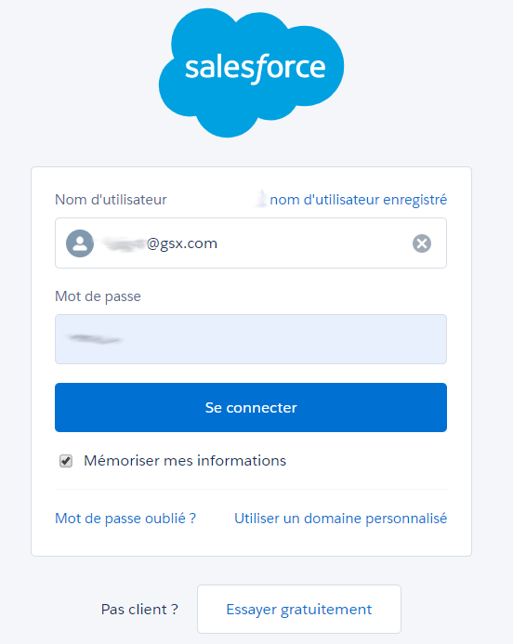

**4/** If it’s done, you will see 

After a few seconds, the Outlook plugin displayed your SalesForce data.  
A new synchronization will begin after few minutes and old and new mails.

